**NETWORK SECURITY ASSIGNMENT#2**

**GROUP 28**

**IIT2018105 BINDU**

**IIT2018118 AYUSHI GUPTA**

**IIT2018120 SANJANA**

**IIT2018138 T S CHINMAY**

**IIT2018147 NILANG VASAVA**

**Question 8: Network - Differentiate Gateway and Router. Justify the need.**

**Ans -**

| **NETWORK EQUIPMENT** | **ROUTER** | **GATEWAY** |
| --- | --- | --- |
| PRIMARY  FUNCTION | It is a hardware device that receives, analyses and transmits the data packets to other networks. | Gateway is essentially a device used to communicate between networks which have a different set of protocols and are responsible for converting one protocol to another. |
| TRAFFIC REGULATION | routers regulate traffic between similar networks | Gateways regulate traffic between two dissimilar networks |
| HOSTED ON | Dedicated appliance  I.e router hardware | Dedicated/virtual appliance or physical server |
| DYNAMIC ROUTING | Dynamic Routing is supported. | Dynamic Routing is not supported |
| WORKING PRINCIPLE | Routing information is achieved for different networks and destination address is the basis for routine traffic | Differentiating that what is inside and what is outside network |
| OSI LAYER | It works on OSI layer 3 and 4. | It works upto layer 5 |

**GATEWAY VS ROUTER:WHEN TO CHOOSE WHICH?**

Suppose there are two networks and computer A belongs to network 1 while computer B belongs to network 2 and they want to communicate with each for the communication ,we will use gateway while for same network communication we would use router.

**NEED FOR GATEWAYS :**

A **gateway** is a node (router) in a computer network, a key stopping point for data on its way to or from other networks. Through gateways, we are able to communicate and send data back and forth. The Internet wouldn't be any use to us without gateways (as well as a lot of other hardware and software).

**NEED FOR ROUTERS :**

**Routers** are responsible for receiving, analysing, and forwarding data packets among the connected computer networks. When a data packet arrives, the router inspects the destination address, consults its routing tables to decide the optimal route and then transfers the packet along this route.

**Question 17: virus, worm, threat, advanced persistent threat, bomb, adware, malware, vulnerability, zero day vulnerability, penetration testing, zero-day attack, Shoulder surfing,keylogger, spyware, Trojan, spear phishing, Social engineering attack, ransomware, rootkit.**

1. **Virus:**

A virus is a PC code or program, which is fit for influencing your PC information seriously by defiling or wrecking them.Computer virus tends to make its copy duplicates at a quick pace, and furthermore spread it over each organizer and harm the information of your PC system.A PC virus is really a pernicious programming program or "malware" that, while contaminating your framework, imitates itself by adjusting other PC programs and embeddings its own code.Ways wherein a virus can influence our PC framework are-by downloading documents from the internet,during the removal of media or drives,through pen drive,through email attachments,through unpatched programming and services,through unprotected or helpless overseer passwords.

1. **Worm:**

A PC worm is an independent PC malware program that duplicates itself so as to spread to different PCs. It frequently utilizes a PC system to spread, depending on security disappointments on the objective PC to get to it.Worms can be sent through programming weaknesses. Or then again PC worms could show up as connections in spam messages or texts (IMs). When opened, these documents could give a connection to a vindictive site or naturally download the PC worm. When it's introduced, the worm quietly goes to work and taints the machine without the client's information. Worms can alter and erase documents, and they can even infuse extra pernicious programming onto a PC. In some cases a PC worm's motivation is just to make duplicates of itself again and again — exhausting framework assets, for example, hard drive space or data transmission, by over-burdening a mutual system. Notwithstanding unleashing ruin on a PC's assets, worms can likewise take information, introduce a secondary passage, and permit a programmer to deal with a PC and its framework settings.

1. **Threat:**

In the field of system security, a threat is a likely negative activity or occasion that encourages a weakness that results in an undesirable effect on a PC framework or application regarding the system. Passive Network Threats: Activities, for example, wiretapping and inactive outputs that are intended to catch traffic going through the system.

Active Network Threats: Activities, for example, Denial of Service (DoS) assaults and SQL infusion assaults where the aggressor is endeavoring to execute orders to upset the system's typical activity.

1. **Advanced persistent threat:**

Advanced persistent threat is an assault wherein unapproved clients access a framework or organize and stay there for an all-inclusive timeframe without being distinguished. Rather, the point of cutting edge steady dangers is regularly information theft.Advanced persistent threat ordinarily have a few stages, including hacking the system, staying away from recognition, developing an assault plan, and planning organization information to recognize where the ideal information is most promptly accessible, gathering touchy organization information, and information spillage .

1. **Adware:**

Adware alludes to a kind of malware that shows undesirable commercials on your PC or gadget. Adware is regularly initiated unwittingly when clients are attempting to introduce genuine applications that adware is packaged with.While here and there, adware can be sheltered, some spring up windows mean to show notices as well as gather information and data so as to target you with redid adverts. In these cases, adware can guide you to malignant sites and tainted pages through different advert joins, putting you in danger of PC infections.

1. **Malware:**

Malware is the aggregate name of various malevolent programming variations, including virus , ransomware, and spyware. On account of vindictive programming, malware normally comprises code created by digital aggressors, intended to make broad harm information and frameworks, or to increase unapproved admittance to the system. Malware is commonly conveyed by means of email as a connection or document. Malware conveys its payload in various manners. From requesting a payoff to taking touchy individual information, cybercriminals are turning out to be increasingly more complex in their strategies.

1. **Vulnerability:**

In cyber security, a vulnerability is a shortcoming which can be misused by a digital assault to increase unapproved admittance to or perform unapproved activities on a PC framework. Vulnerability can permit assailants to run code, access a framework's memory, introduce malware, and take, decimate or change touchy information. To abuse a vulnerability an assailant must have the option to associate with the PC framework.

1. **Zero day vulnerability:**

A zero-day vulnerability is a vulnerability in a framework or gadget that has been unveiled however isn't yet fixed. An endeavor that assaults a zero-day vulnerability is known as a zero-day abuse. Since they were found before security analysts and programming designers got mindful of them—and before they can give a fix—zero-day vulnerability represent a higher danger to clients for the accompanying reasons: Cybercriminals race to misuse these weaknesses to take advantage of their plans Weak frameworks are uncovered until a fix is given by the seller.

Zero-day vulnerabilities are ordinarily engaged with focused assaults; in any case, numerous missions despite everything utilize old vulnerability.

1. **Penetration testing:**

Penetration testing, additionally called pen testing or ethical hacking, is the act of testing a PC framework, system or web application to discover security weaknesses that an assailant could misuse. Penetration testing can be mechanized with programming applications or performed physically. In any case, the cycle includes gathering data about the objective before the test, recognizing conceivable passage focuses, endeavoring to break in - either basically or without a doubt - and revealing back the findings.The primary goal of Penetration testing is to distinguish security shortcomings. Penetration testing can likewise be utilized to test an association's security strategy, its adherence to consistency prerequisites, its workers' security mindfulness and the association's capacity to distinguish and react to security occurrences.

1. **Zero day attack:**

If a hacker manages to exploit the vulnerability before software developers can find a fix, that exploit becomes known as a zero day attack.Zero day vulnerabilities can take almost any form, because they can manifest as any type of broader software vulnerability.This makes zero day vulnerabilities difficult to proactively find—which in some ways is good news, because it also means hackers will have a hard time finding them. But it also means it’s difficult to guard against these vulnerabilities effectively.

1. **Shoulder surfing:**

In PC security, shoulder surfing is a sort of social designing procedure used to get data, for example, individual ID numbers (PINs), passwords and other private information by investigating the casualty's shoulder, either from keystrokes on a gadget or touchy data being spoken and heard, otherwise called listening in.

1. **Keylogger:**

A keylogger is a program that records the keystrokes on a PC. It does this by observing a client's information and keeping a log of all keys that are squeezed. The log might be spared to a document or even sent to another machine over a system or the Internet. Keylogger programs are regularly esteemed spyware since they as a rule run without the client knowing it. They can be malignantly introduced by programmers to keep an eye on what a client is composing. By analyzing the keylog information, it might be conceivable to discover private data, for example, a username and secret phrase mix. Hence, keyloggers can be a huge security hazard in the event that they are accidentally introduced on a PC.

1. **Spyware:**

Spyware is undesirable programming that invades your figuring gadget, taking your web utilization information and touchy data. Spyware is named a kind of malware — malevolent programming intended to access or harm your PC, regularly without your insight. Spyware assembles your own data and transfers it to sponsors, information firms, or outer users.Spyware is utilized for some reasons. Typically it intends to track and sell your web utilization information, catch your Visa or ledger data, or take your own personality. How? Spyware screens your web action, following your login and secret word data, and keeping an eye on your touchy information.Some kinds of spyware can introduce extra programming and change the settings on your gadget, so it's essential to utilize secure passwords and keep your gadgets refreshed.

1. **Trojan:**

A Trojan horse, or Trojan, is a kind of pernicious code or programming that looks authentic however can assume responsibility for your PC. A Trojan is intended to harm, upset, take, or when all is said in done, exactly some other hurtful activity on your information or network.A Trojan acts like a genuine application or record to deceive you. It looks to delude you into stacking and executing the malware on your gadget. Once introduced, a Trojan can play out the activity it was planned for.A Trojan is once in a while called a Trojan virus or a Trojan horse virus, yet that is a misnomer. Virus can execute and repeat themselves, A Trojan can't. A client needs to execute Trojans. All things being equal, Trojan malware and Trojan virus are frequently utilized reciprocally.

1. **Spear phishing:**

Spear phishing is an email or electronic correspondences trick focused on a particular individual , association or business. In spite of the fact that it is regularly expected to take information for noxious purposes, digital lawbreakers may likewise mean to introduce malware focused on a client's PC. This is the manner by which it works: An email shows up, evidently from a reliable source, however rather it drives the unconscious beneficiary to a counterfeit site loaded with malware. These messages frequently utilize sharp strategies to draw casualties out into the open. For instance, the FBI has cautioned of lance phishing tricks where the messages gave off an impression of being from the National Center for Missing and Exploited Children.

1. **Social engineering attack:**

Social engineering is the term used for awide range of malicious activities carried out through human interactions. It uses psychological manipulation to trick users into making security mistakes or delivering sensitive information.Social engineering attacks are taking place in one or more steps.Social engineering attacks are taking place in one or more steps. In the first place, the perpetrator investigates the intended victim in order to gather the necessary background information, such as potential entry points and weak security protocols, needed to proceed with the attack. The attacker then moves to gain the victim's trust and to provide incentives for subsequent actions that break security practises, such as revealing sensitive information.

1. **Ransomware:**

Ransomware is a sort of vindictive programming ( malware) that takes steps to distribute or square information or PC framework access, as a rule by scrambling it, until the casualty pays the assailant a payment fee.There are various vectors ransomware can take to get to a PC. One of the most widely recognized conveyance frameworks is phishing spam — connections that go to the casualty in an email, taking on the appearance of a record they should trust. When they're downloaded and opened, they can assume control over the casualty's PC, particularly in the event that they have inherent social designing instruments that stunt clients into permitting managerial access. Some other, more forceful types of ransomware, as NotPetya, misuse security gaps to contaminate PCs without expecting to deceive clients.

1. **Rootkit:**

A rootkit is a vindictive programming that permits an unapproved client restricted admittance to a PC and its product's limited areas.This programming stay covered up in the PC and permit the aggressor distant admittance to the computer.Rootkit establishment can be robotized, or an assailant can introduce it subsequent to having acquired root or Administrator access. Acquiring this entrance is an aftereffect of direct assault on a framework, for example abusing a referred to weakness, (for example, benefit acceleration) or a secret key (got by breaking or social designing strategies like "phishing".

1. **Bomb:**

A logic bomb is a malevolent program that is set off when a consistent condition is met, for example, after various exchanges have been prepared or on a particular date (likewise called a delayed bomb). Malware, for example, worms frequently contain logic bombs, which act in one way and afterward change strategies on a particular date and time.

**Q16.Practical : Penetration testing -**

Penetration testing, also called pen testing or ethical hacking, is the practice of testing a computer system, network or web application to find security vulnerabilities that an attacker could exploit. Penetration testing can be automated with software applications or performed manually. Either way, the process involves gathering information about the target before the test, identifying possible entry points, attempting to break in -- either virtually or for real -- and reporting back the findings.The main objective of penetration testing is to identify security weaknesses. Penetration testing can also be used to test an organization's security policy, its adherence to compliance requirements, its employees' security awareness and the organization's ability to identify and respond to security incidents.

**Causes of vulnerabilities -**

**Poor design and implementation**

**Poor system Configuration**

**Insecure Network**

**System Complexities**

**Human Error**

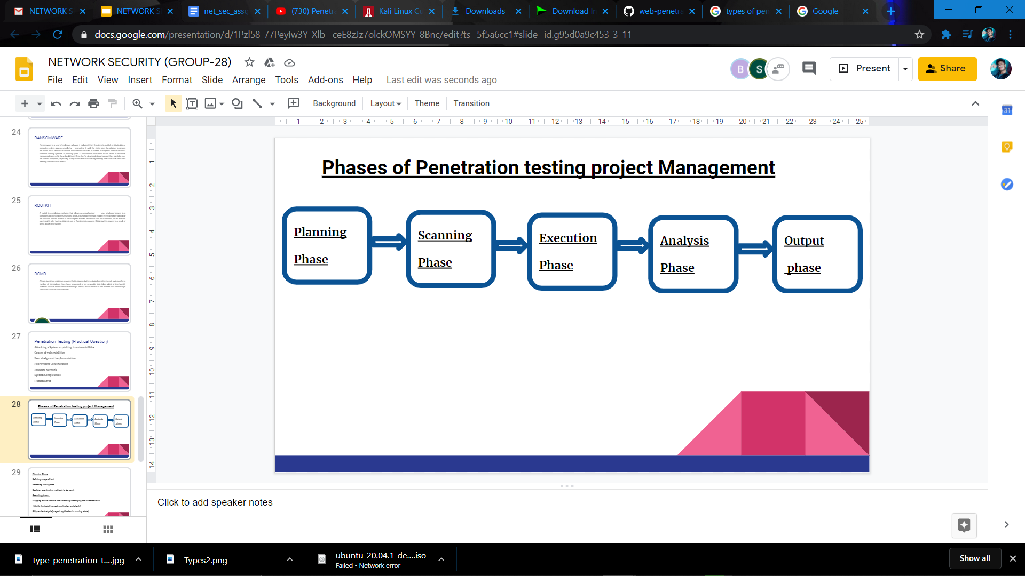

**Planning Phase -**

**Defining scope of test**

**Gathering intelligence**

**Decision over testing methods to be used.**

**Scanning phase -**

**Mapping attack vectors and detecting/identifying the vulnerabilities**

**1.Static Analysis( Inspect application code logic)**

**2.Dynamic Analysis(Inspect application in running state)**

**Execution Phase -**

**Crucial phase where actual damage is done.**

**Analysis phase -**

**Collect the evidences of exploited vulnerabilities .**

**Categorize the level of risk .**

**Reporting the (result to execution manager).**

**Output phase -**

**Results of penetration testing are compiled into a detailed report.**

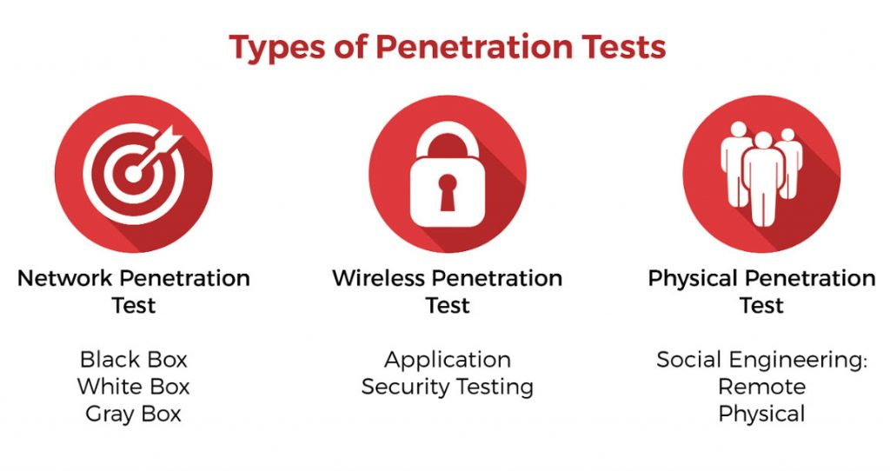

Tools used for Pen-testing -

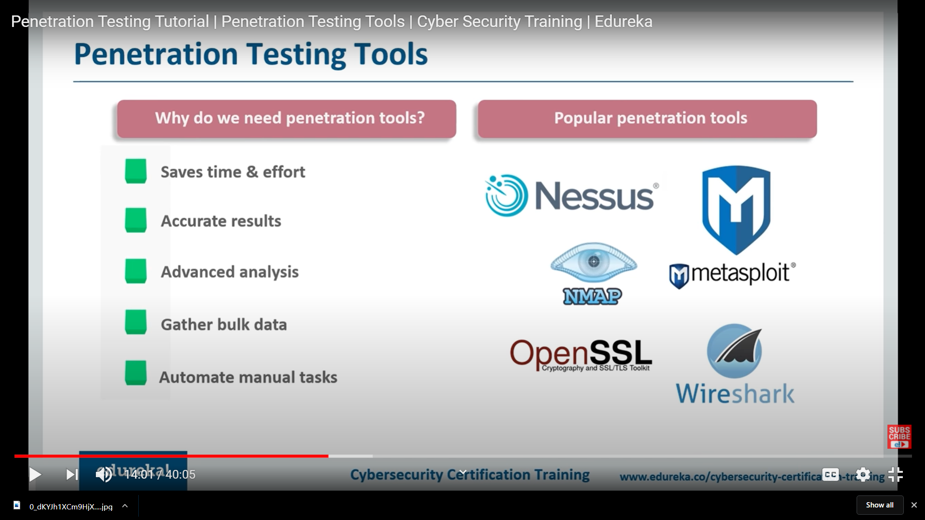

1.Nessus

2.Metasploit

3.Nmap

4.OpenSSL

5.Wireshark

METASPLOIT UNLEASHED REQUIREMENTS

Before learning how to use the Metasploit Framework, we first need to make sure that our setup will meet or exceed the system requirements outlined in the following sections. Taking the time to properly prepare your *Metasploit Lab Environment* will help eliminate many problems before they arise later in the course. We highly recommend using a system that is capable of running multiple [virtual machines](https://www.offensive-security.com/metasploit-unleashed/requirements/#metasploit-virtual-machine) to host your labs.

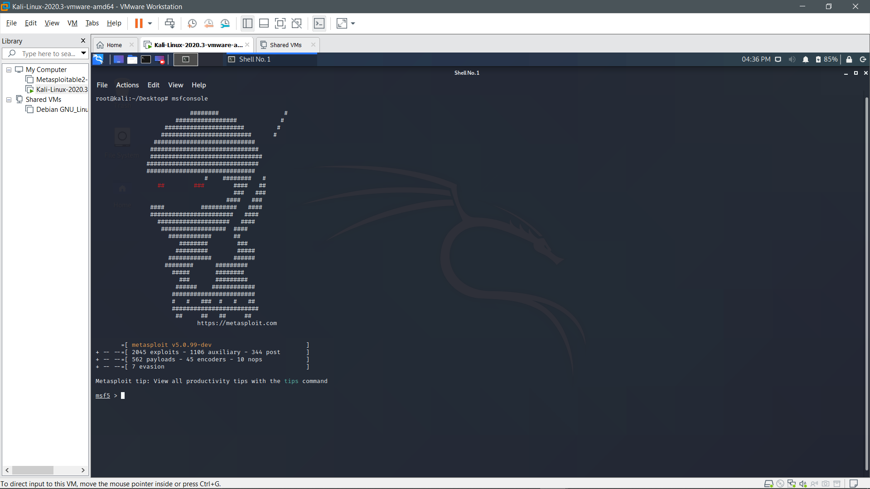

## **METASPLOIT UNLEASHED HARDWARE REQUIREMENTS**

<https://www.offensive-security.com/metasploit-unleashed/requirements/>

#### 

#### 

#### 

## **METASPLOIT UNLEASHED SOFTWARE REQUIREMENTS**

#### **HYPERVISOR**

#### **KALI LINUX**

#### **METASPLOITABLE**

One of the problems you encounter when learning how to use an exploitation framework is trying to find and configure targets to scan and attack. Luckily, the Metasploit team is aware of this and released a vulnerable VMware virtual machine called ‘Metasploitable’.Metasploitable is an intentionally vulnerable Linux virtual machine that can be used to conduct security training, test security tools, and practice common penetration testing techniques. The VM will run on any recent VMware products and other visualization technologies such as VirtualBox. You can download the image file of [Metasploitable 2 from SourceForge](http://sourceforge.net/projects/metasploitable/files/Metasploitable2/).

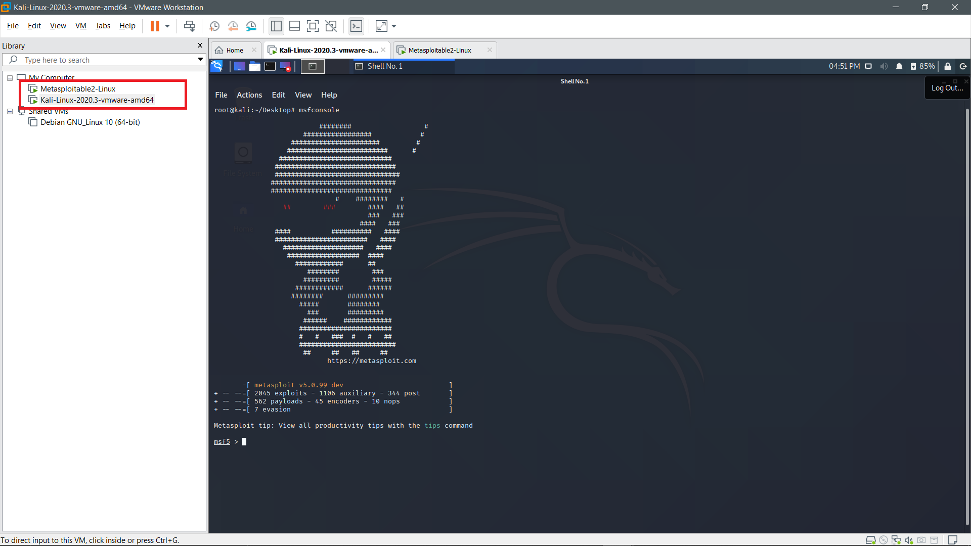

Setting up Metasploitable(is a host).

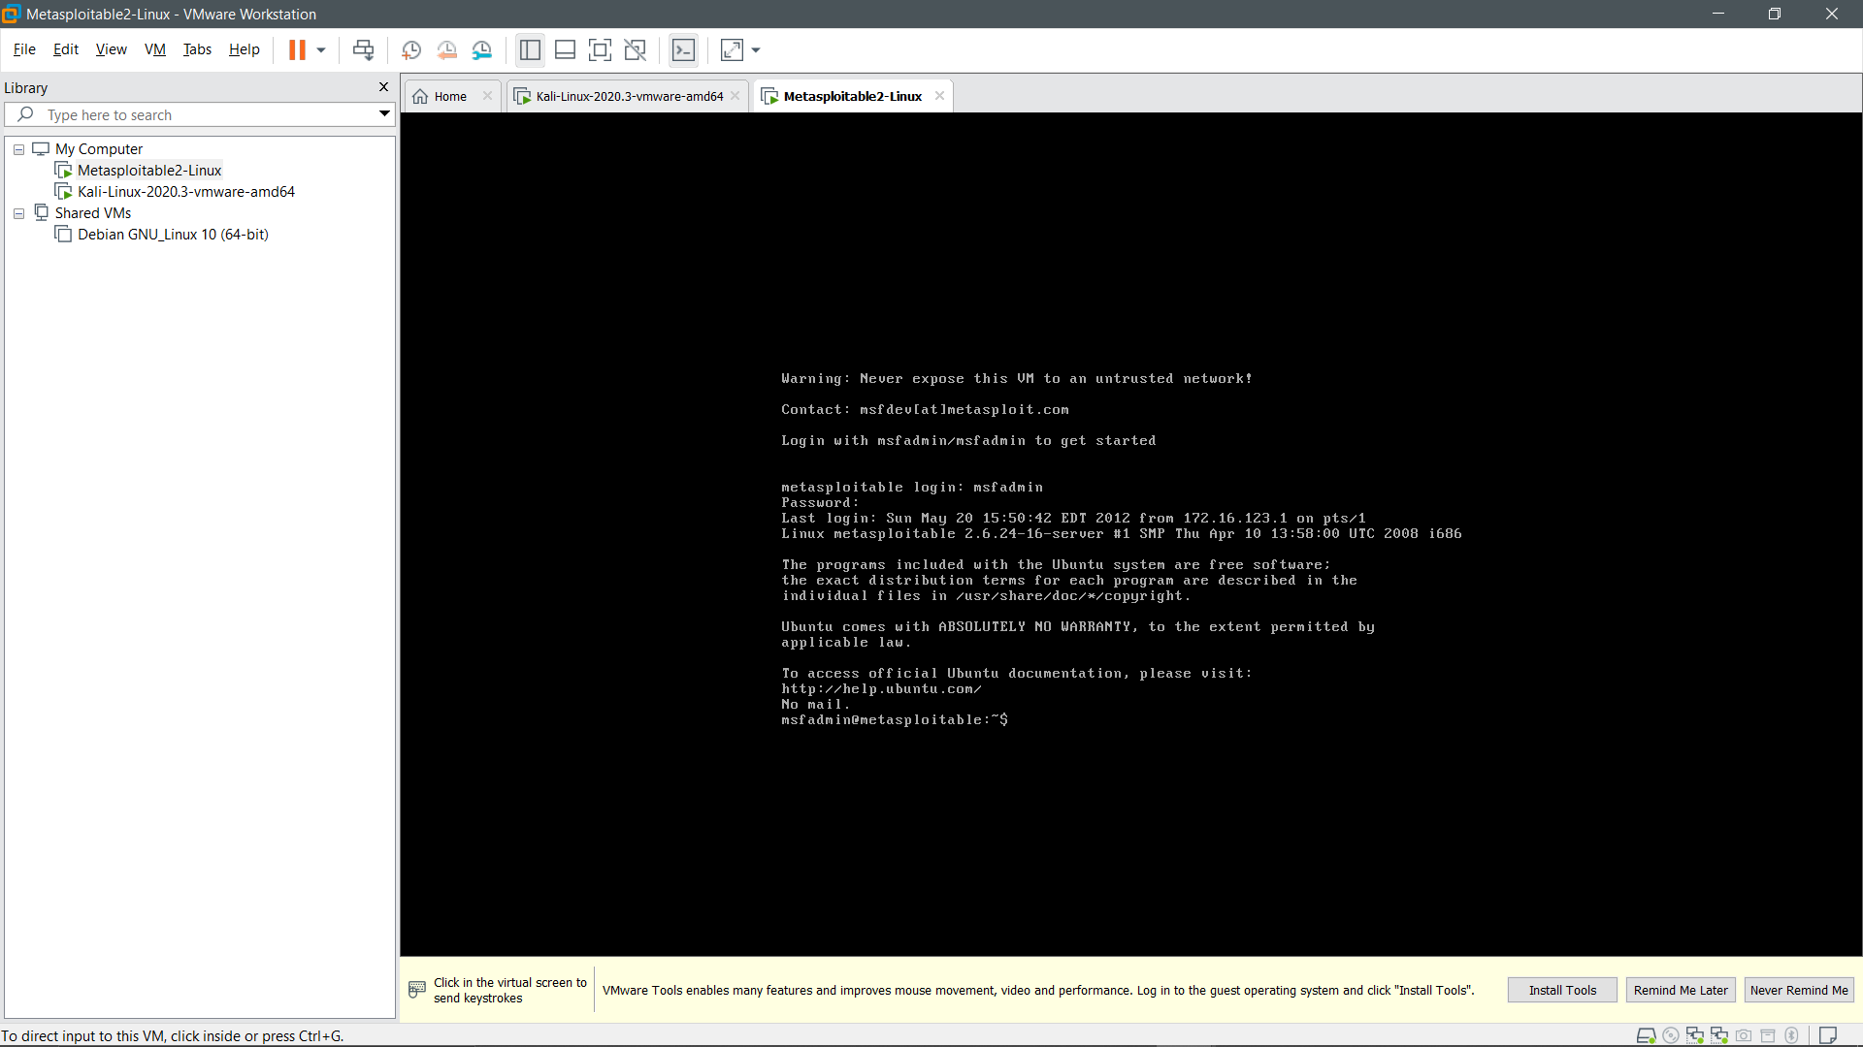

See the ip address of both attacker (kali) and host(metasploitable) .

Using ifconfig command.

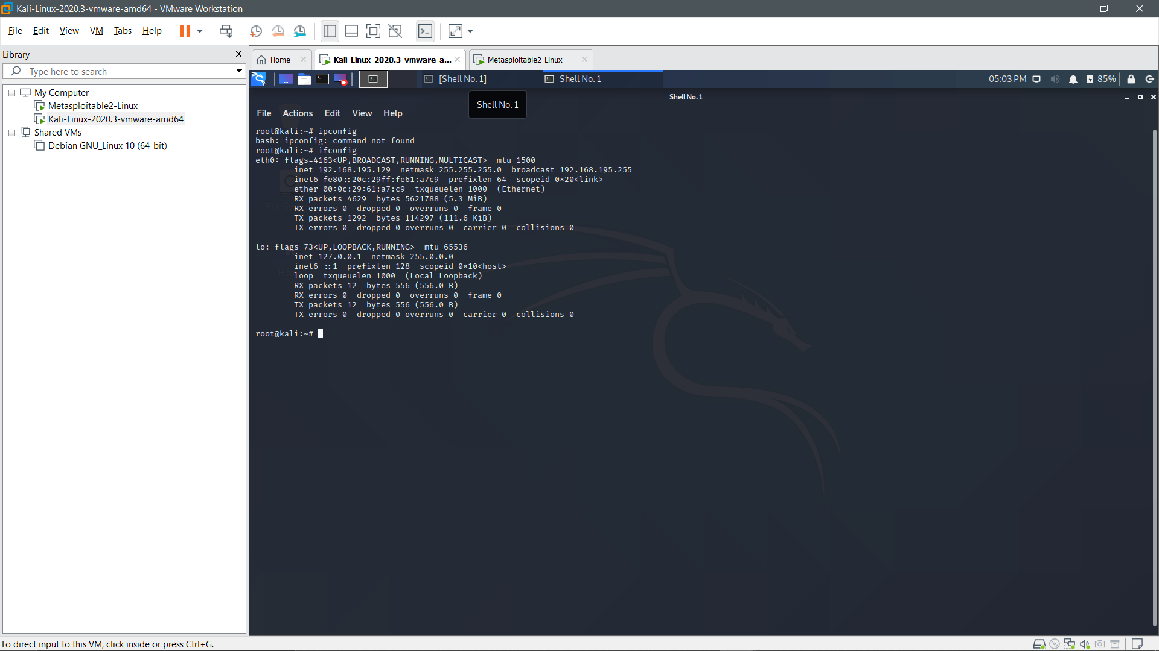

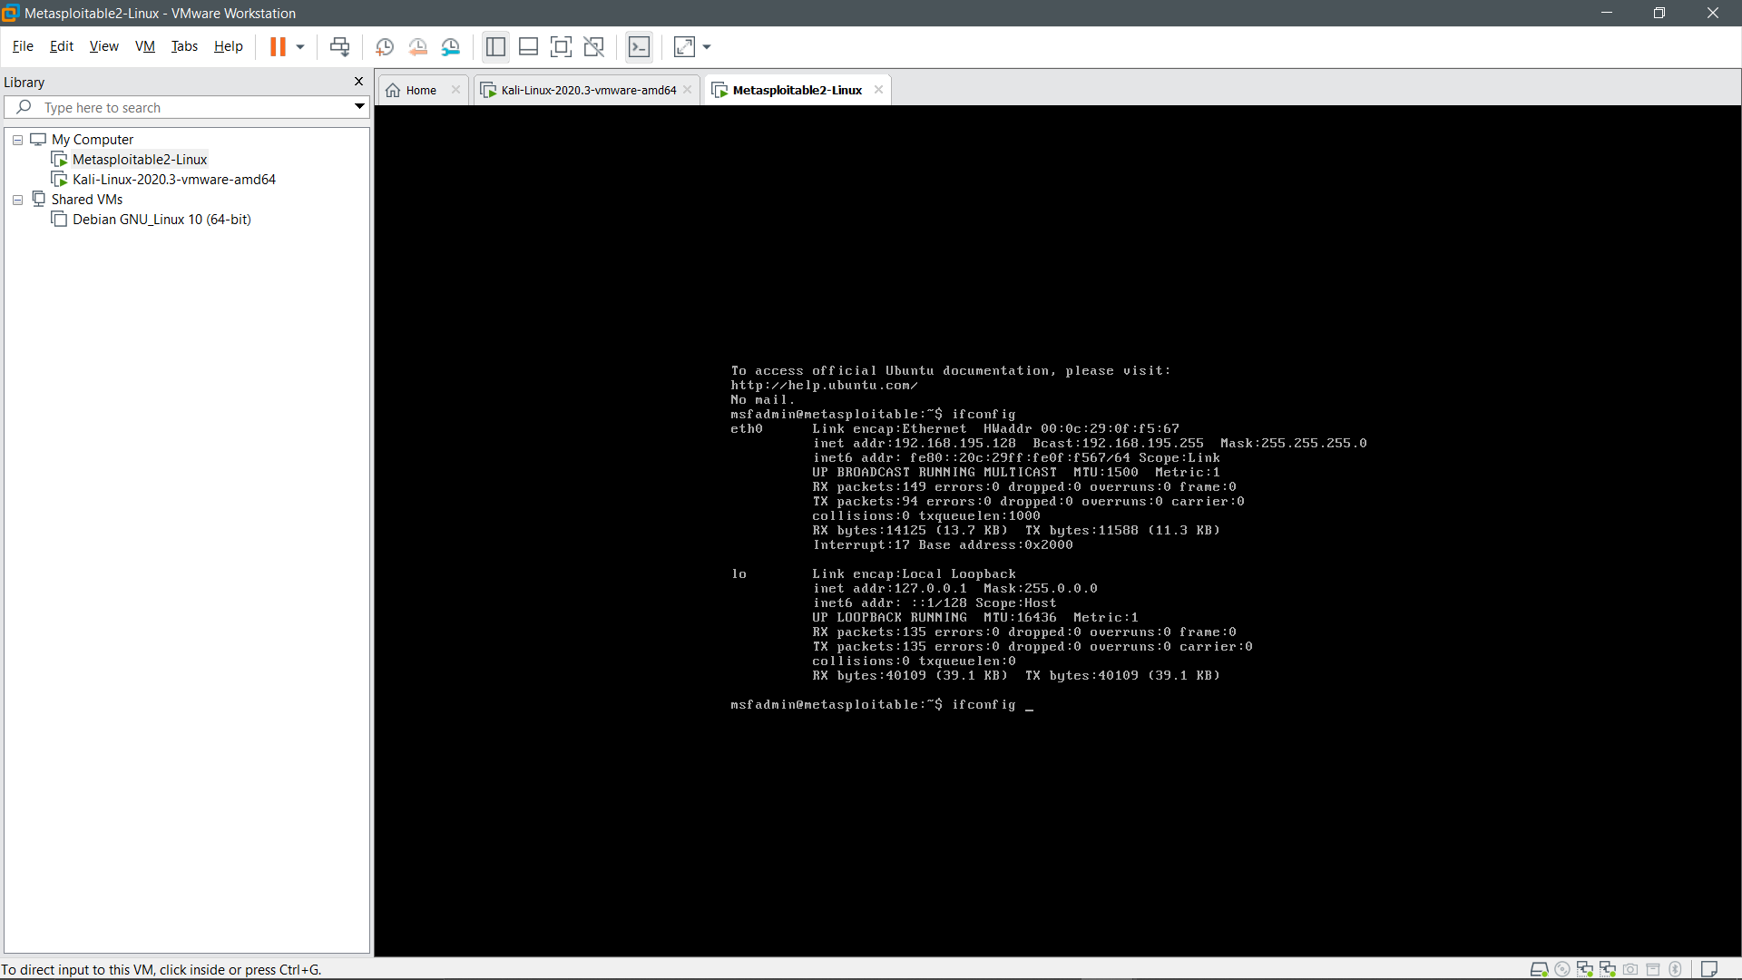

Launching metasploit using command msfconsole

.